**Exercise 1: Setting Up Junit**

**pom.xml**

<?xml version="1.0" encoding="UTF-8"?>  
<project xmlns="http://maven.apache.org/POM/4.0.0"  
 xmlns:xsi="http://www.w3.org/2001/XMLSchema-instance"  
 xsi:schemaLocation="http://maven.apache.org/POM/4.0.0  
 http://maven.apache.org/xsd/maven-4.0.0.xsd">  
  
 <modelVersion>4.0.0</modelVersion>  
  
 <groupId>org.example</groupId>  
 <artifactId>Settingupjunit</artifactId>  
 <version>1.0-SNAPSHOT</version>  
  
 <properties>  
 <maven.compiler.source>21</maven.compiler.source>  
 <maven.compiler.target>21</maven.compiler.target>  
 <project.build.sourceEncoding>UTF-8</project.build.sourceEncoding>  
 </properties>  
  
 <dependencies>  
 <dependency>  
 <groupId>junit</groupId>  
 <artifactId>junit</artifactId>  
 <version>4.13.2</version>  
 <scope>test</scope>  
 </dependency>  
 </dependencies>  
</project>

**Calculator.java**

public class Calculator {  
 public int add(int a, int b) {  
 return a + b;  
 }  
}

**CalculatorTest.java**

import org.junit.Test;  
import static org.junit.Assert.*assertEquals*;  
  
public class CalculatorTest {  
  
 @Test  
 public void testAdd() {  
 Calculator calc = new Calculator();  
 int result = calc.add(2, 3);  
 *assertEquals*(5, result);  
 }  
}

**Output:**

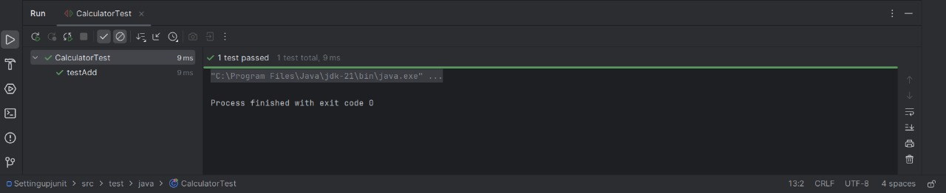

**Exercise 3: Assertions in JUnit**

**Pom.xml**

<?xml version="1.0" encoding="UTF-8"?>  
<project xmlns="http://maven.apache.org/POM/4.0.0"  
 xmlns:xsi="http://www.w3.org/2001/XMLSchema-instance"  
 xsi:schemaLocation="http://maven.apache.org/POM/4.0.0 http://maven.apache.org/xsd/maven-4.0.0.xsd">  
 <modelVersion>4.0.0</modelVersion>  
  
 <groupId>org.example</groupId>  
 <artifactId>AssertionsinJUnit</artifactId>  
 <version>1.0-SNAPSHOT</version>  
  
 <properties>  
 <maven.compiler.source>21</maven.compiler.source>  
 <maven.compiler.target>21</maven.compiler.target>  
 <project.build.sourceEncoding>UTF-8</project.build.sourceEncoding>  
 </properties>  
  
 <dependencies>  
 <dependency>  
 <groupId>org.junit.jupiter</groupId>  
 <artifactId>junit-jupiter</artifactId>  
 <version>5.10.0</version>  
 <scope>test</scope>  
 </dependency>  
 </dependencies>  
  
 <build>  
 <plugins>  
 <plugin>  
 <groupId>org.apache.maven.plugins</groupId>  
 <artifactId>maven-surefire-plugin</artifactId>  
 <version>3.1.2</version>  
 </plugin>  
 </plugins>  
 </build>  
</project>

**AssertionsTest.java**

package org.example;  
  
import org.junit.jupiter.api.Test;  
import static org.junit.jupiter.api.Assertions.*;  
  
public class AssertionsTest {  
  
 @Test  
 public void testAssertions() {  
 *assertEquals*(5, 2 + 3);  
 *assertTrue*(5 > 3);  
 *assertFalse*(5 < 3);  
 *assertNull*(null);  
 *assertNotNull*(new Object());  
 }  
}

**Output:**

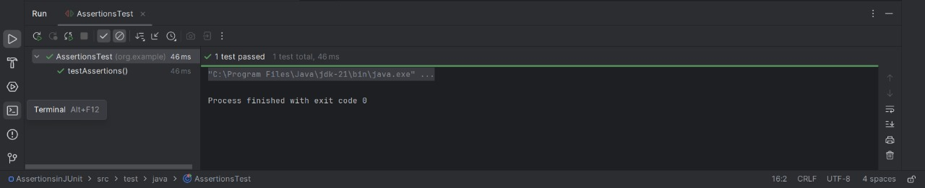

**Exercise 4: Arrange-Act-Assert (AAA) Pattern, Test Fixtures, Setup and Teardown Methods in JUnit**

**Pom.xml**

<?xml version="1.0" encoding="UTF-8"?>

<project xmlns="http://maven.apache.org/POM/4.0.0"

xmlns:xsi="http://www.w3.org/2001/XMLSchema-instance"

xsi:schemaLocation="http://maven.apache.org/POM/4.0.0 http://maven.apache.org/xsd/maven-4.0.0.xsd">

<modelVersion>4.0.0</modelVersion>

<groupId>org.example</groupId>

<artifactId>assertionjunit</artifactId>

<version>1.0-SNAPSHOT</version>

<properties>

<maven.compiler.source>21</maven.compiler.source>

<maven.compiler.target>21</maven.compiler.target>

<project.build.sourceEncoding>UTF-8</project.build.sourceEncoding>

</properties>

<dependencies>

<dependency>

<groupId>junit</groupId>

<artifactId>junit</artifactId>

<version>4.13.2</version>

<scope>test</scope>

</dependency>

</dependencies>

</project>

**Calculator.java**

public class Calculator {

public int add(int a, int b) {

return a + b;

    }

}

**CalculatorTest.java**

import org.junit.After;

import org.junit.Before;

import org.junit.Test;

import static org.junit.Assert.assertEquals;

public class CalculatorTest {

private Calculator calculator;

@Before

public void setUp() {

System.out.println("Setting up...");

calculator = new Calculator();

}

@After

public void tearDown() {

System.out.println("Cleaning up...");

calculator = null;

}

@Test

public void testAdditionOfTwoPositiveNumbers() {

int result = calculator.add(5, 3);

assertEquals(8, result);

}

@Test

public void testAdditionOfNegativeAndPositiveNumber() {

int result = calculator.add(-2, 4);

assertEquals(2, result);

    }

}

**Output:**

